**CASH FLOW DOCUMENTATION**

A statement of cash flow is a financial document used in conjunction with balance sheets and income statements. Companies will use these financial statements to create a complete financial report.

The below link leads to the Economic Viability:

[S1.- Economic Viablity.xlsx](https://docs.google.com/spreadsheets/d/1IqXhbGNB2awalN9h0mpop3EdCRJC8l8B/edit#gid=606687104)

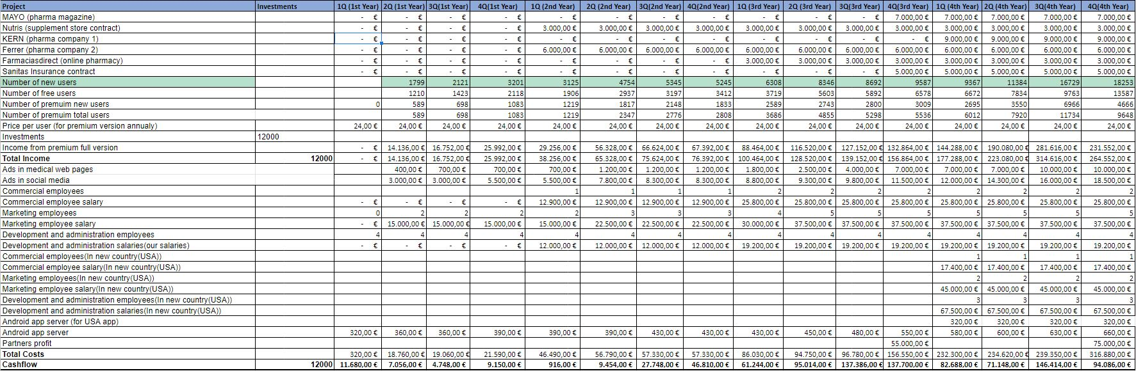

**Our resources of Income**

We will have more than one resource for income which are:

1. Signing contracts: One of our main resources of income is signing contracts with pharmacies, pharmacists companies and supplement companies, so we are going to put some ads in our application to get revenue from them. In the list of contracts in our Incomes (from rows 5 - 10: all those rows are showing the contracts that we are going to login in different fields and with different companies), we will start signing our contracts from the 1st quarter of the 2nd year; this is because we will hire our first commercial employee at the 1st quarter of the 2nd year by then, who would initiate the contracting process with respect to the Incomes. So the signing contract income is related to the number of commercial employees as shown in the previous figure (cash flow table). We will start getting more revenue from contracts when we will hire more commercial employees and also it is related to the number of users who are using our app because when we have more users we can convince more companies to sign with us.

We would sign contracts with the pharma and supplement companies (as mentioned from rows 5 - 10) to display their ads in our application which would be the source of Income, they are:

* MAYO: Mayo is a company with Spanish capital with headquarters in Barcelona and delegation in Madrid that dedicates its main activity to the training of professionals in human and animal health, and the creation of strategic scientific communication solutions for the pharmaceutical sector.  
     
  This company supports the pharmaceutical industry in the development of its marketing actions and creates continuous training, communication and publication projects together with scientific societies and patient associations.  
     
  This company offers many options to shape communication campaigns to reach the target audience with relevant content, at the right time and through the most appropriate channel.   
  This is the link to their website: [MAYO comunicamos salud](http://www.edicionesmayo.es/en/index.php)
* Nutris: Nutris is a Spanish company, based in Madrid, specialized in the healthcare field, including food & food supplements, medical nutrition and sport nutrition. Focused in research, development and manufacturing of nutraceutical products.  
  This is the link to their website: [Ingredients | Healthcare | Nutris Ingredients | Madrid](https://www.nutris.es/)
* KERN: Kern Pharma has a formulary that covers 90% of prescription needs. Its portfolio is made up of more than 230 products in more than 660 different presentations that seek to provide solutions to patients and healthcare professionals.   
  This is the link to their website: [Kern Pharma](https://www.kernpharma.com/es)
* Ferrer: Ferrer is a vertically integrated organization. They offer truly innovative therapeutic solutions in 3 areas, namely: Hospital products, Prescription products and self-care products. In addition, they collaborate in the creation and support of foundations, continuous training of health professionals and are close to patients to detect unmet needs and provide solutions.  
  This is the link to their website: [Ferrer: Inicio](https://ferrer.com/es)
* Farmaciasdirect: Farmaciasdirect was started in 2015, the year in which it was validated for the sale of EFP (advertising pharmaceutical specialties), appearing in the register of pharmacies authorized for online sales, which is operated by the Spanish Agency for Medicines and Health Products.  
    
  Currently, farmaciasdirect.com has established itself as one of the main channels for purchasing pharmacy and parapharmacy products, not only for offering the best prices on the market, but also for offering a quality service and proximity.  
  This is the link to their website: [Tu Farmacia Online y Parafarmacia Online.](https://www.farmaciasdirect.com/)
* Sanitas: With more than 20 years since its creation, the Sanitas Foundation is conceived as an element of health promotion and social transformation through research, the social integration of people with disabilities and the recognition of medical teaching. Supporting inclusive sport, research and health dissemination in Spain, the development of digital tools and the excellence of the best medical professionals, the Sanitas Foundation develops its objectives of social change, equal access to health and well-being of people.   
  This is the link to their website: [Sanitas al cuidado del bienestar de las personas](https://corporativo.sanitas.es/)

1. Premium users/subscriptions: One of our main resources of income is getting revenue from users by creating a premium version of our application that has more features (like setting alarms and getting caution notifications) than the free one. We will price our premium subscription for 2€ monthly (24€ yearly) which is a very fair and cheap price compared to what our app is offering.
2. Investments: We have added an additional column for the initial investment of 12000€ for our company which would be as a startup in order to give a push to the company’s financial growth.

**Our Costs**

We will have more than one costs which includes:

1. Salaries: There would be 3 different salaries that will be included which are:
2. Commercial Employee salary: The commercial employees are those employees who deal with the relationship and financial factors of the company in getting new contracts for the growth of the company. Moreover, like a Business developer.  
   The salaries of the commercial employees have been kept lower in the 2nd year because of the number of the commercial employees. We would contract more number of employees after the 2nd year when the need arises.  
   This is the link for the average salary of a commercial employee (in Spain): <https://www.glassdoor.es/Sueldos/spain-commercial-manager-sueldo-SRCH_IL.0,5_IN219_KO6,24.htm?countryRedirect=true>
3. Marketing Employee Salary: The marketing employees are those employees who monitor market trends, create advertising campaigns, develop pricing strategies and target strategies based on demographic data and work with the company to develop more awareness of what they offer. We will start to hire the marketing team from the 2nd quarter of the 1st year and provide their salaries that would benefit us to achieve users from the 2nd quarter.

This is the link for the average salary of a marketing employee (in Spain): <https://www.glassdoor.es/Sueldos/madrid-marketing-sueldo-SRCH_IL.0,6_IM1030_KO7,16.htm?countryRedirect=true>

1. Development and Administration salary: The Development and Administration is a team that runs the process of guiding an organisation toward the achievement of progressive political, economic and social objectives that are authoritatively determined in one manner or the other. In our case, we as a team have decided to work in the development part and develop the application. This team would be responsible for taking important decisions about the various business factors.  
   The Development and Administration team’s salary would also be initiated from the 2nd year with low salary and then we will increase it in the upcoming years. This is because we are parties in this business so we have to invest more on it especially in the first two years to be a successful business in the future.  
     
   **New country (U.S.A.)***:* In the cash flow sheet, we see that there are replicated rows that includes the commercial, marketing and the development & administration team. In the first quarter of the fourth year we will take a decision to expand our business, so in the fourth year we will start preparing to start the business. These rows are added as we plan to start our business in the U.S. and we have included approximate values of salaries to each of them as per the latest reports.  
   The reason to choose the U.S for starting our business is because the salaries there are greater than the salaries in Europe. Hence, it would be a boost in the financial growth of our company.
2. Servers: An app hosting platform can cost around 320€/quarter which would be increased as the development of the application changes/modifies with new/updated features. The cost of the server increases when the number of users increases.
3. Advertisements: We have divided the ad postings on the medical website pages and on social media sites (like Facebook,Instagram and Youtube). For the ad postings, we have invested more on social media platforms than on medical websites. This is because now-a-days, people spend most of their time on social media more than on medical sites. The number of users are related to ads because the more we invest in advertisements the more we will get more new users. As shown in the previous figure, the number of users are increasing while the amount of investment on the advertisements gets increased.

**Our Workzone**

We have decided to create a virtual office and work as an online company as it would lead to cost reduction and reduce other expenses that includes the different equipment, electricity, etc.

In addition, our application is an online service so there would be online contact with our customers to solve their queries.

We have decided to assign the following post:

*Chief Executive Officer*: Yoon

*Chief Technology Officer*: Eyad

*Chief Marketing Officer*: Marc

*Chief Financial Officer*: Ronnel

In the workforce, we as a team ourselves have decided to build and develop the application. We are trying to follow the American system such that every employee has their own equipment to work on. It will be better to reduce the cost. Also our workforce will increase every year or maybe quarter because we will get new users so we need more employees to manage and organize the business.

Below gives the description of each of the tabs mentioned in the economic viability:

**NPV**

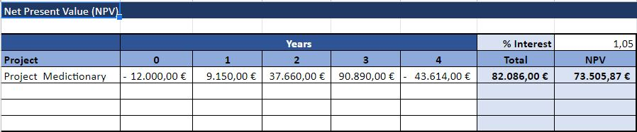

In the NPV sheet, the values for each year have been received on the basis of the cash flow sheet with respect to every single quarter in every year. The first year of the NPV sheet value would be the cash flow of the last quarter of the first year in the cashflow. The values of the remaining years in the NPV sheet would be achieved by calculating the total of the income and cost subtraction quarterly and then we implement the NPV formula.  
*Note:* We have added our investment as the initial investment in the 0th column (-12000 €)

**IRR**

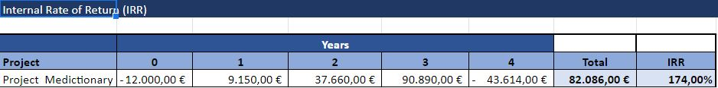

The calculation in the NPV sheet yearly values are the same in the IRR sheet as well and then we implement the IRR formula.

**Payback**

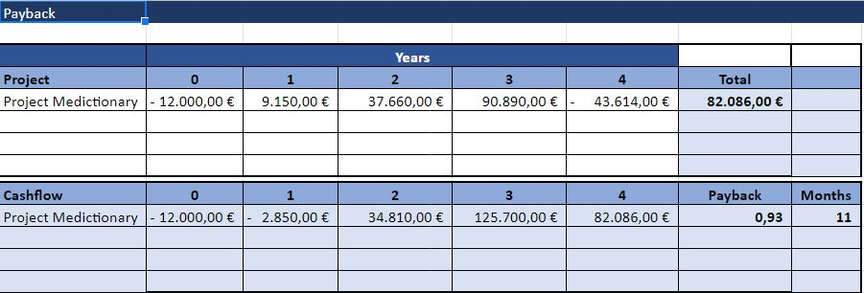

For the Payback, the values are achieved by summing up the previous year’s value with the IRR and NPV and then we implement the Payback formula.

**What-if**

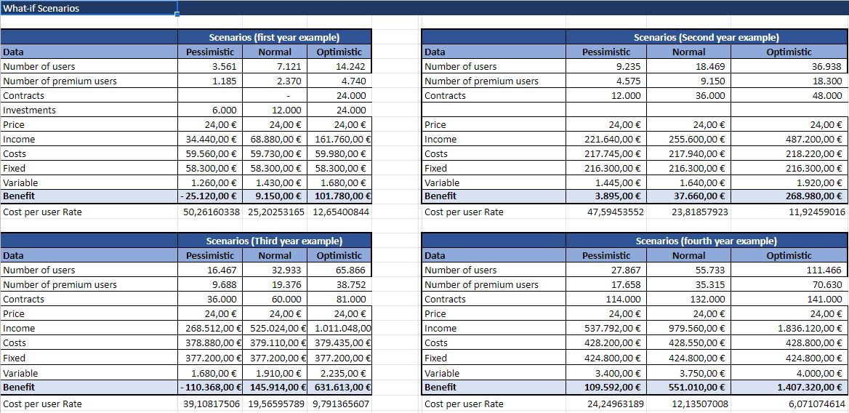

In the What-if scenario, we will see the 3 different users and the estimation of their values:

*Pessimistic*: The values in this column have been achieved on the basis of the Normal users. These values should be half of the Normal users (50%). We tried to assume the worst case scenario and we found that when we decrease it by 50% it will be the worst case.

*Normal*: The values in this column have been achieved on the basis of the total number of users from the cash flow sheet for a particular year. For example, in the first year example, we have included a sum of the total number of users of all the quarters of the 1st year. Also the cost and income had been taken from the cash flow sheet.

*Note:* The ‘Fixed’ are the fixed costs that will never be changed in our table that includes salaries and advertisement.The variable one that includes the server cost (Firebase).

*Optimistic*: The values in this column have been achieved on the basis of Normal users. These values should be double or more than the Normal users (100%). We tried to assume the best case scenario and we found that when we increase it by 100% it will be the best case.

Cost per user rate has also been included in the sheet. We achieve these values while calculating the cost per the number of premium users.

We added the cost per user rate row to calculate the percentage of losing and gaining money in the pessimistic and optimistic. As per the above figure, there is a change in the percentage every year. For example, in the first year, we will lose around 50% if we faced pessimistic scenario and we will gain around 12.6% if we face an optimistic scenario. It will be the same idea with the other years but with different rates.